Key Learning Objectives for YR children

To say the number names 0 to 10 and then 20 in the correct order and then backwards

Steps to Success
- Say the number names in order out loud - start with number 1.
- Say the number names in order out aloud counting back from 10 to 0
- Then extend to and back from 20
- Practice counting forwards and backwards from different starting points (not always 0 or 20)

Top Tips
- Learn counting nursery rhymes and songs such as ‘1,2,3,4,5… once I caught a fish alive’, ‘10 fat sausages sizzling in a pan’, ‘1 man and his dog’
- Count out aloud as you march along
- Play count down to 0 for a rocket lauch e.g. 10..9..8 etc to blastoff
- Pay particular attention to the 11,12, 13,15 as these don’t follow a set pattern and can be tricky to learn

To count 10 things accurately, then to 20

Steps to Success
- Pick up and move one object at a time.
- Touch, count and say the number name as you move and put the object down.
- Know that if we re-arrange the objects, the quantity is the same e.g.
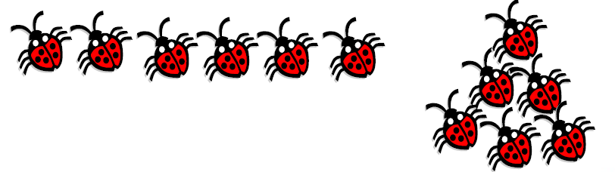
Top Tips
- Move the objects as you count them into a line so you know that they have been counted
- Count all sorts of things..leaves, socks, forks, toy cars, peas, pencils etc
- Ensure accurate counting

To recognise the numbers 0 to 20 and match digits 0-20 to a set of objects

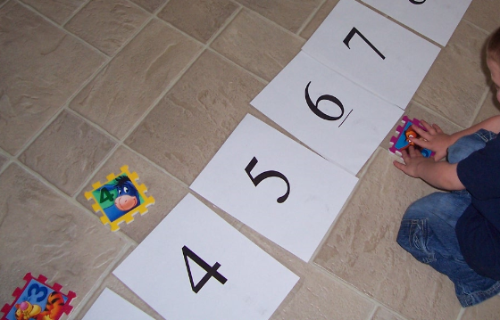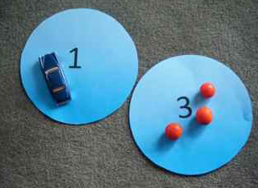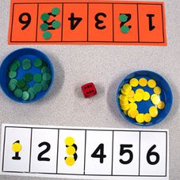

Steps to Success
- Start with numbers 0-5 then 6-10 then 11-14 then 15-20
- Spotting patterns in the numbers is really important e.g.
- Linking numbers to counting is really important e.g. use of a number line-
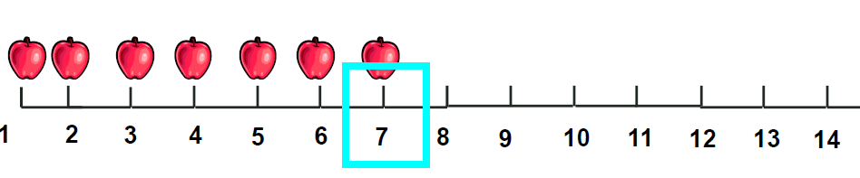

Top Tips
- What numbers can you see around the house, in the street, in the shops?
- Match number cards/ jigsaw pieces of the same number
- Match number card to a set of objects
- Using post-its or pieces of paper to write numbers to show how many items are needed e.g. forks for dinner, cars in the garage
- Play dice games- match the number on the dice to a number card. Which number did you throw the most?
To order digits 1-10

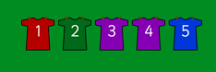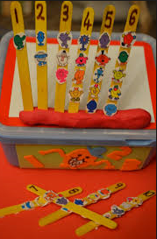

Steps to Success
- Start with numbers 1-5 then 6-10
- Know that numbers get bigger

Top Tips
- Put the cards in the right order for Mr Muddle
Write numbers 0-10

Top Tips
- Try to encourage writing numbers in a context e.g. keeping a score, number for a birthday card, role play
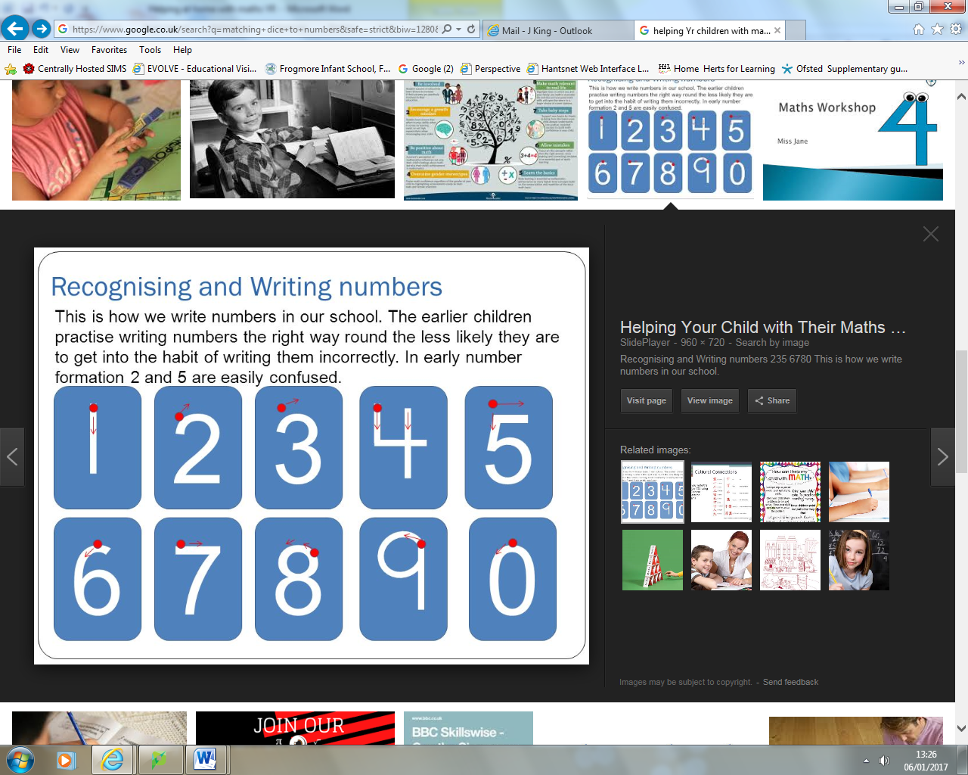

To know some double numbers to 12

Steps to Success
1. double 1 is 2, double 2 is 4 etc

Top Tips
- Use games such as dice games, dominoes, target games/darts with doubles
- Use hands to reinforce e.g. 5 fingers and 5 fingers is 10 fingers altogether
To use words like more or less, greater or fewer, heavier or lighter

Top Tips
- Children watch an adult use the language when counting, weighing and measuring
- Who has the most? How has the least? Who has the fewest?

To find one more or one less than a number from 1 to 10

Steps to Success
1. Count out the given number of objects.
2. Add one more (or one less)
3. Count again.

Top Tips
- Use a number line or objects to help (use giant indoor and outdoor numberlines)
- Use songs such as Ten Green Bottles, and Five Current Buns
- Roll a dice, ad done more to the number

To combine groups of objects to find a total

Steps to Success
- Put objects together.
- Put objects in a line.
- Count objects from left to right, saying the number name as you touch each object. How many do you have altogether?
- Start with up to 5 objects then extend to 10.

Top Tips
- Do not use formal recording e.g. sums
- Check your answer by counting again.
- Count animals in two fields, peas on two plates of food

To take away using objects

Steps to Success
1. Take away the given number of objects one at a time (put in a different place)
2. Count how many objects you have left.

Top Tips
- Do not use formal recording e.g. sums
- Check your answer by counting again.
- Play games such as… If 2 sheep run away how many will be left? If I eat 3 peas how many will be left?
To talk about and make patterns

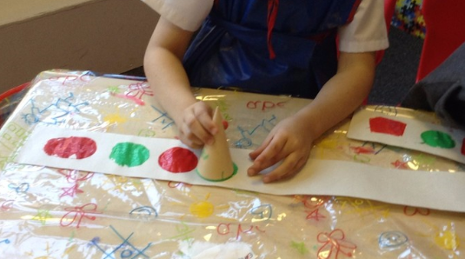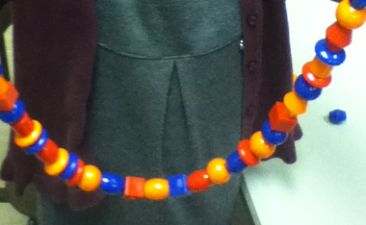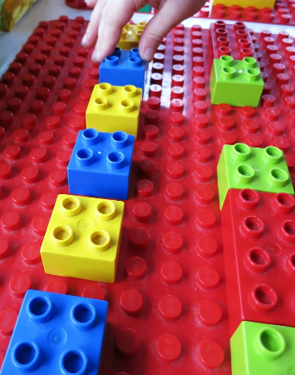

Top Tips
- Use a variety of objects, shapes, sizes etc
- Use terms such as ‘repeating’.

To name some flat (2D) shapes

Top Tips
- Describe a 2D shape without using its name, i.e. by describing its properties
- Identify shapes which are not square, round …
- Understand and use in a practical context the vocabulary: shape,
flat, straight, curved, round, corner, side, edge, sort, circle, triangle,
rectangle, square.
- Identify circles, squares, triangles and rectangles.
- Feel a shape in a bag and name it.
- Talk about the shapes and patterns in their environment
To name some solid (3D) shapes

Top Tips
- Identify solid shapes that can be seen around the school and environment
- Start to be aware of some properties of solid shapes
- Make models using 3D shapes- junk modelling and talk about the shapes
- Begin to name solids such as cube, cone and sphere
- Understand use in a practical context: shape, solid, hollow,
- edge, face, straight, curved, point, corner

To use words like, under, over, behind, next, in front

Top Tips
- Use stories, small world play, playground games and familiar
Contexts to introduce additional language:
between across through backwards forwards
sideways opposite
To solve problems involving sharing

Steps to Success
1. This is about sharing thing equally (fairly)

Top Tips
- Make sure this is done practically e.g. share the biscuits between the three bears, share the cars so each garage has the same number
- Can you put the apples into bags of 4?
To solving problems involving halving

Steps to Success
- This needs to be done practically so that children understand halving something as sharing equally between two or cutting into equal sized pieces

Top Tips
- Find opportunities to do practically and model the language e.g. Half the playdough, we need half of the ribbon, the jug is half full

Useful websites
www.happychild.org.uk/wks/math/key1
www.topmarks.co.uk
www.bbc.co.uk/schools/ks1bitesize/numeracy
ictgames
crickweb

