At Frogmore Infant School we follow our school values:  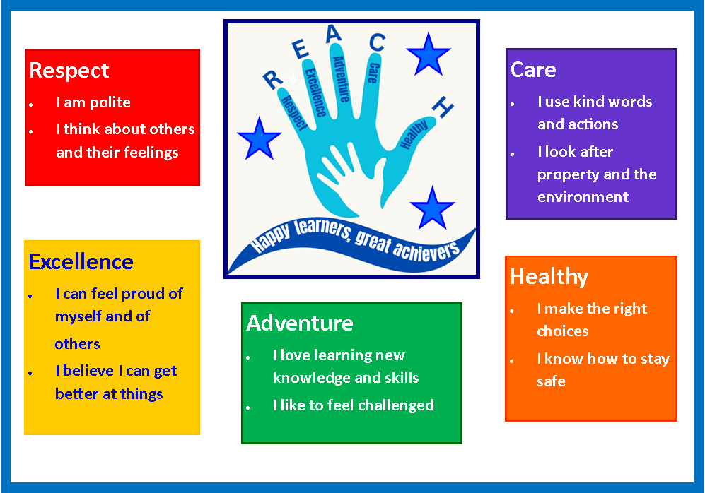  So that everyone: |  | We use our traffic lights to help to ensure everyone feels safe  and can learn:  At our school we do not tolerate any form of bullying~  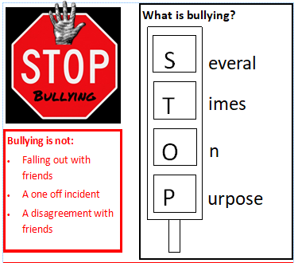  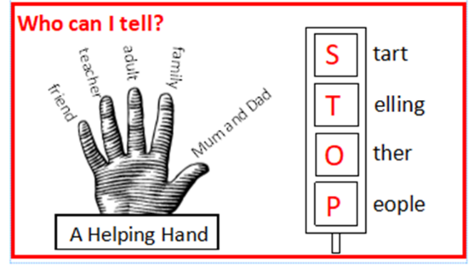
  Feels  safe |  | Can learn
  Great job!  Following values so everyone is safe and can learn |  | Caution!  Need a warning to follow values so everyone is safe and can learn |  | Stop and think!  Preventing self and others from being safe and learning
    - ‘Well done’  - Sticker  - Value hands  - Frog award  - Green Play |  | 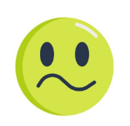  Adults will help you to regulate  Adults will help you to understand your behaviour

